Metrics: 7.1.9 Friendliness Resources available for Differently abled

The institute claims 6 and above option regarding the resources available to the differently abled students. Summarized Friendliness Resources available for Differently abled (Divyangjan) in the institute are as below:

1. Physical facility
JJT University provides various physical facilities which are beneficial for the differently abled students. All the listed facilities are available in ground floor.
• Provision for Lift
• Ramp / Wheelchair
• Rest Room
• Scribes for Examination
• Any other Similar Facility

2. Provision for Lift
The institute has availability of lift facility for Differently Abled (Divyangjan)
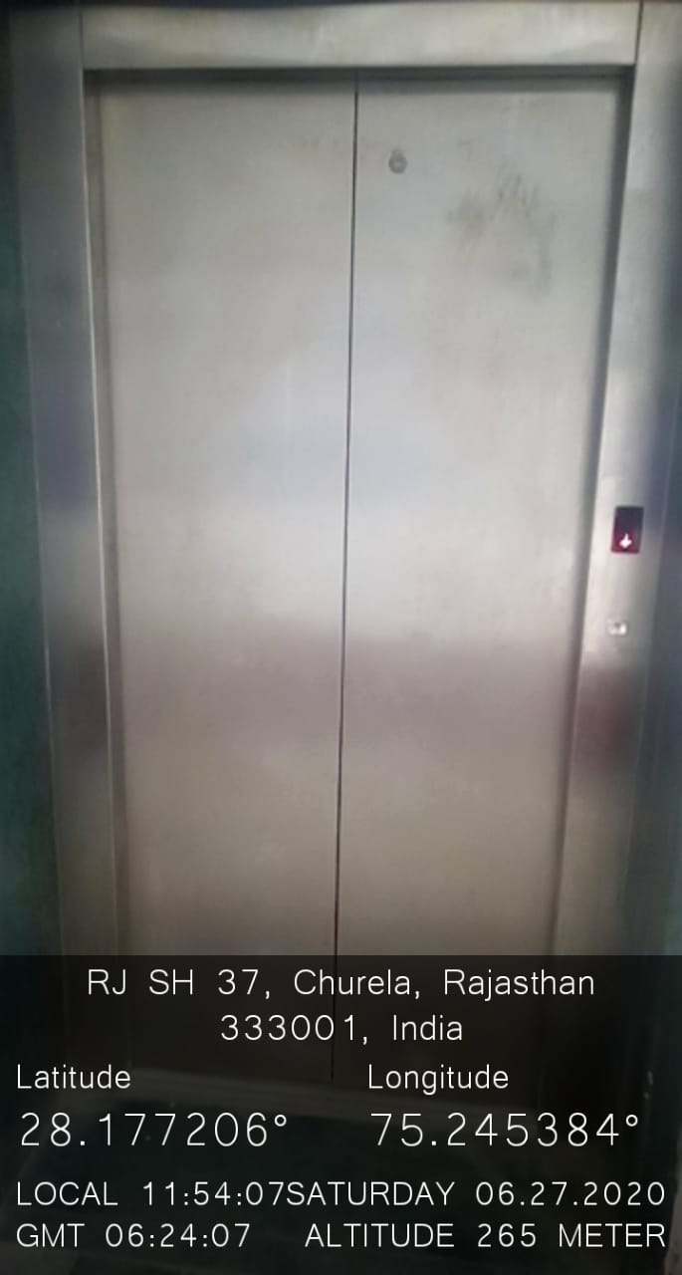

3. Ramp
Institute has ramp facility for Differently Abled (Divyangjan). Wheelchair is available in the campus for the Differently abled (Divyangjan) students/staff or injured.
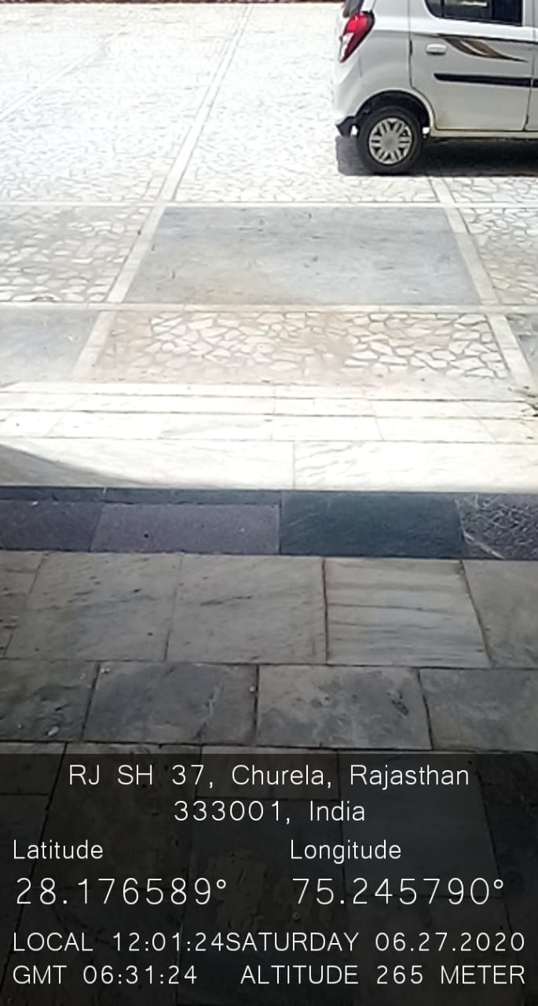
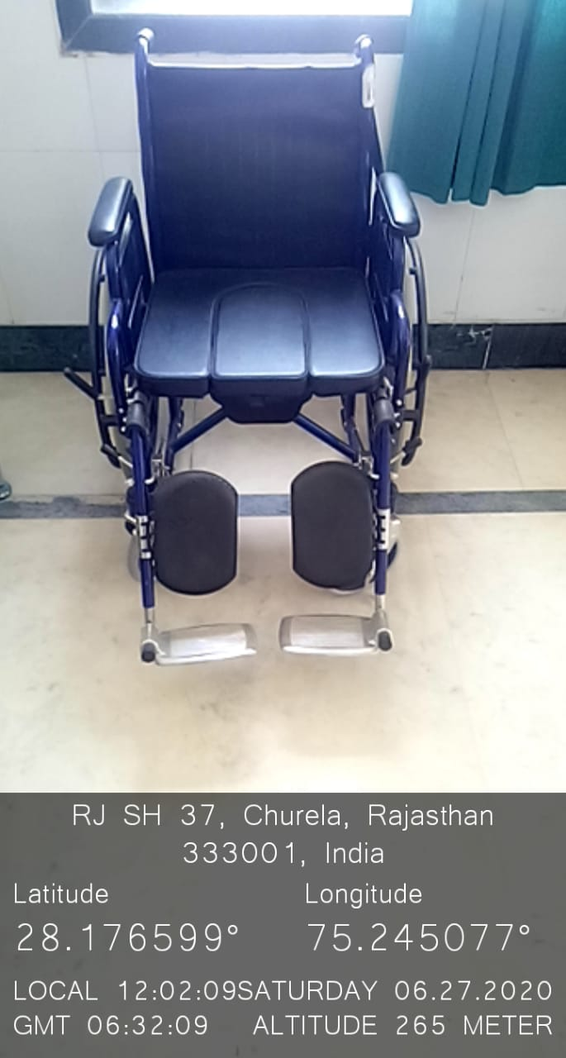

4. Rest Room

5. Scribes for Examination

As per the instructions of Shri JJT University, the institute provides scribes facility for Differently abled (Divyangjan) / injured student who are unable to write their examination.
6. Any Other similar facility
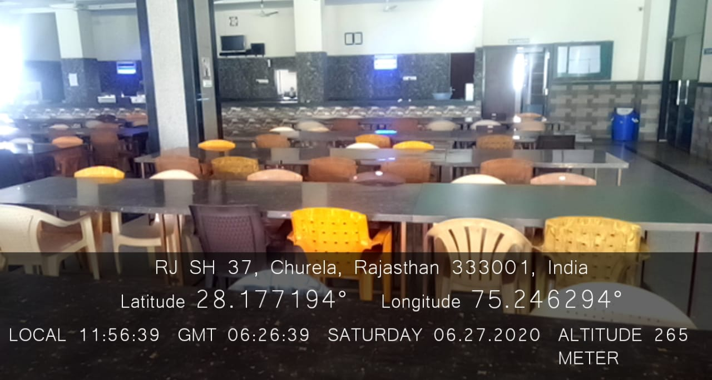
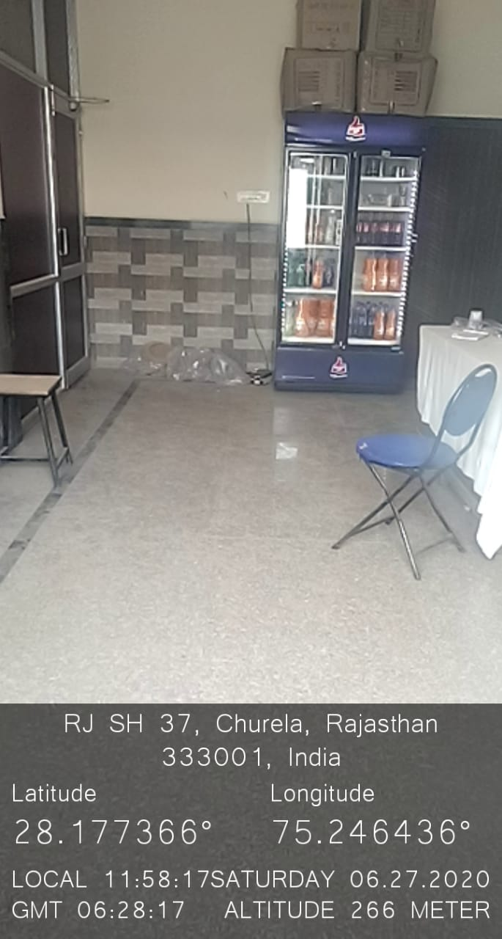

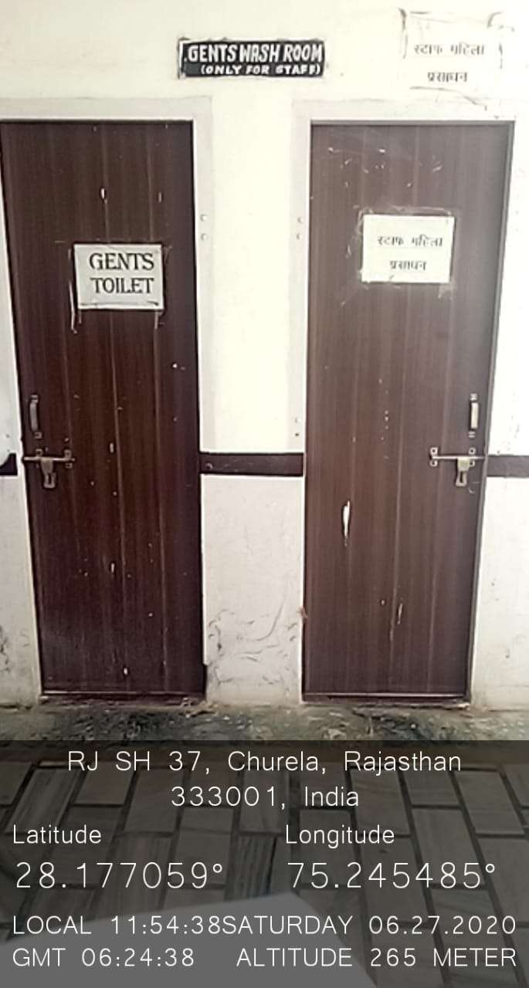
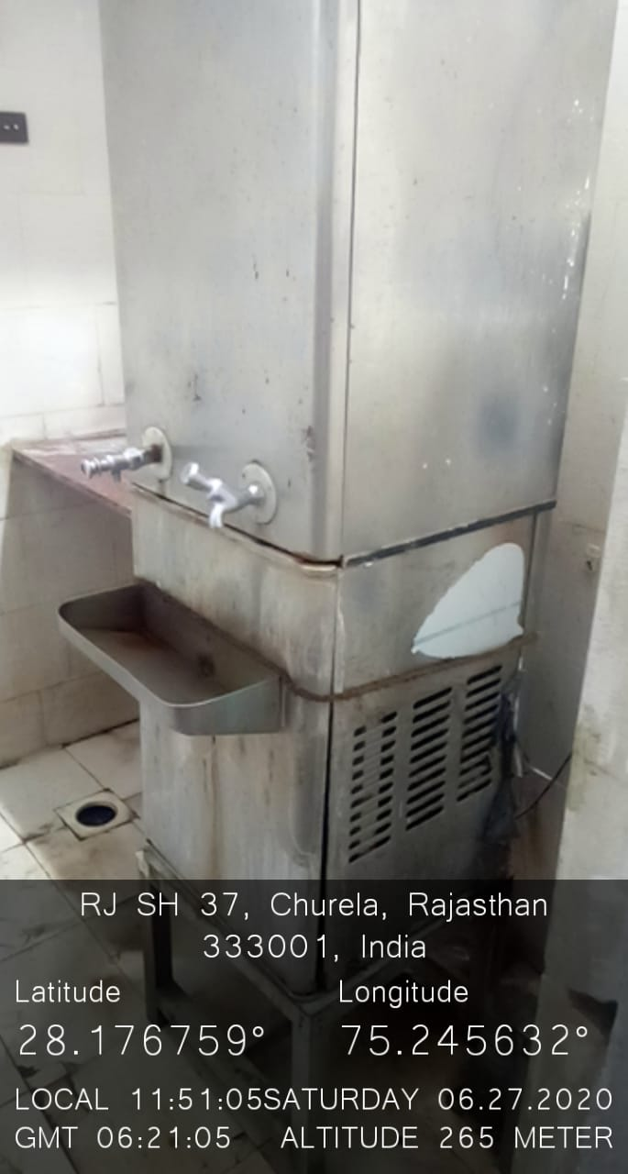
Canteen Provisional Store

Washroom Water

